Remote Control Using Keyboard

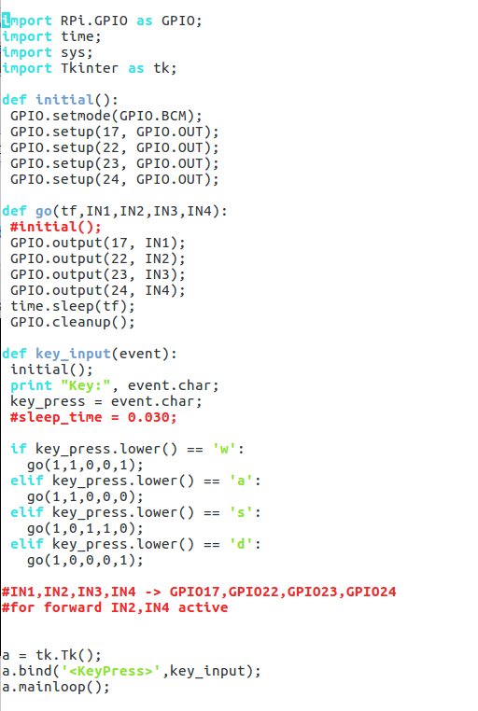

Open the vnc viewer to access the pi and run this code from there...

